Teste API com Erro:

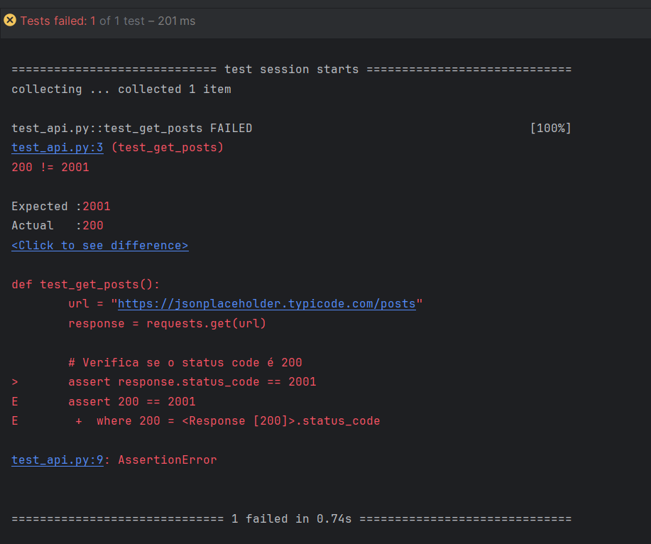

—----------------------------------------------------------------------------------------------------------------

Teste API sem Erro:

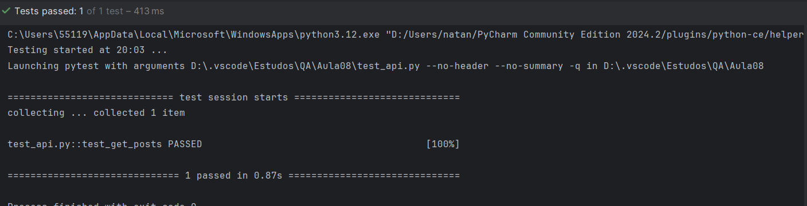

—----------------------------------------------------------------------------------------------------------------

Teste Create (Post):

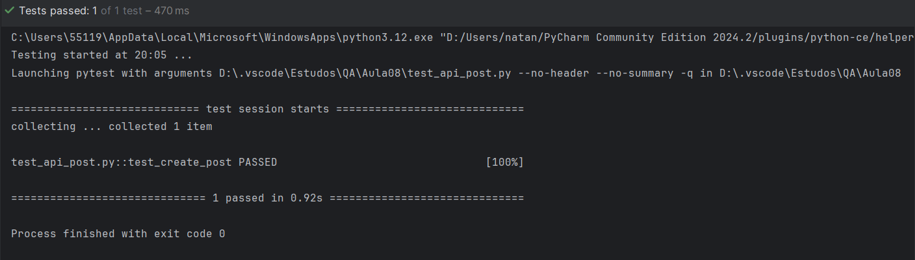

—----------------------------------------------------------------------------------------------------------------

Teste Update (Put) com erro:

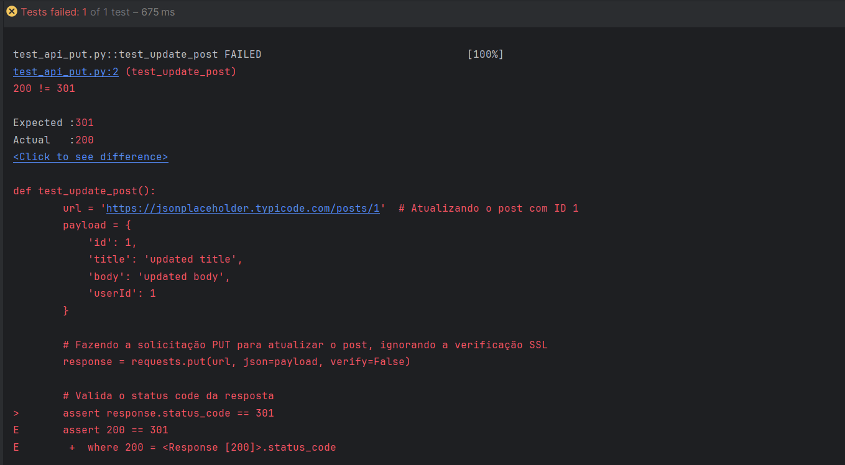

—----------------------------------------------------------------------------------------------------------------

Teste Update (Put) sem erro:

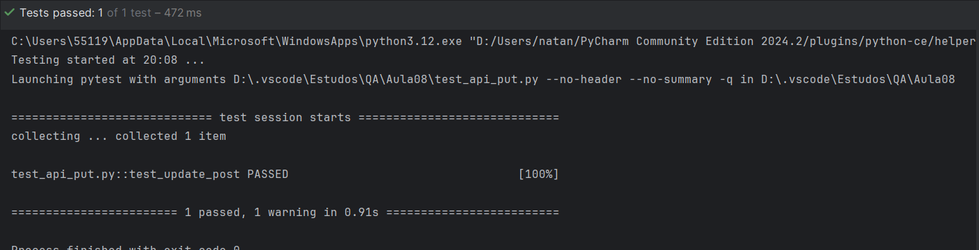

—----------------------------------------------------------------------------------------------------------------

Teste Delete (Delete) com erro:

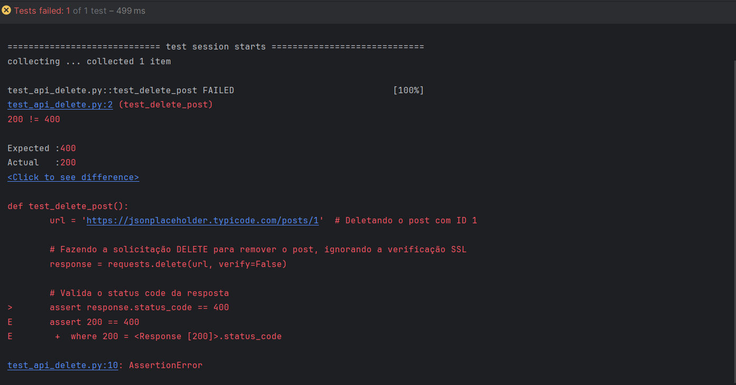

—----------------------------------------------------------------------------------------------------------------

Teste Delete (Delete) sem erro:

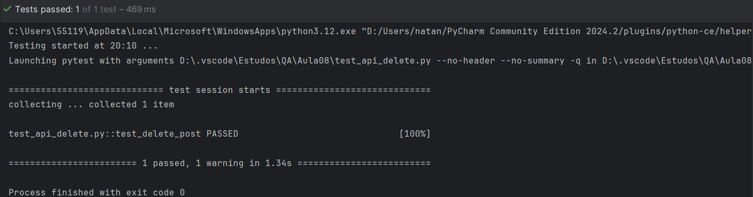

—----------------------------------------------------------------------------------------------------------------

Carla Gamarano RA 49939 Natan Alexandre RA 44261 Victor Bertolino RA 48547